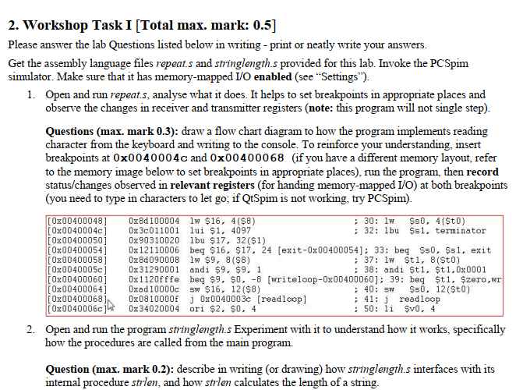

|  |  |
| --- | --- |
| 0xffff0000 | Receiver control |
| 0xffff0004 | Receiver data |
| 0xffff0008 | Transmitter Control |
| 0xffff0012 | Transmit data |

